Supplementary Information

NRF2 metagene signature is a novel prognostic biomarker in colorectal cancer

Séan M. O’Cathail¹ *ǂ, Chieh-Hsi Wu² ǂ, Annabelle Lewis³, Chris Holmes^{2,4,5}, Maria A Hawkins¹, Tim Maughan¹
* Corresponding author
ǂ Denotes equal contribution

Construction of the NRF2 expression in the training set
The flowchart on the left in Figure S2 depicts the procedure for deriving the NRF2 expression in the training set and further details are provided below.
Unsupervised dimension reduction
The metagene approach has the advantage of preserving statistical power. If all the candidate genes were included in an analysis, the statistical power would be exhausted. Of the NRF2 regulated genes found in lung cancer, 36 genes demonstrated differential expression and were in the training set. In the training set, these 36 genes were represented by 92 probes, where 65 of the 92 probes had an absolute correlation (in expression) >0.5 with at least another probe. This indicated potentially strong dependencies among the probes and so the expression levels measured by the 92 probes could be represented by a smaller number of variables. This was likely due to multiple probes matching to the same gene symbol and co-expression of genes in the NRF2 pathway. Such correlations in the covariates would create multi-collinearity in the downstream regression analysis, leading to unreliable parameter estimation. Therefore, it was desirable to obtain a simplified aggregate of NRF2 representation, which was achieved by applying principal component analysis (PCA) to the candidate NRF2 target genes. PCA was suitable because, in the presence of high correlation among probes, the majority of the variation in the data could be explained by a smaller set of principal components (PCs). Thus PCA could provide a simpler representation of the expression data. Furthermore, the PCs would be uncorrelated among themselves, which eliminated the problem of multi-collinearity in the regression analysis downstream.
PCA produced a new set of continuous variables, which were weighted averages of all the probe expressions. Subsequently, we filtered out PCs that explained too little variation in the expression data and only retained the “major PCs”, which were the most variable PCs that explained up to 80% of the variation in the expression data. Such filter was applied because each of the excluded PCs represented too little variation and was roughly the same amount as that explained by other excluded PCs. Often, such minor PCs would have arbitrary probe weights, so should not be interpreted. Through this, we obtained 11 major PCs that explained up to 80% of the variation in the 92 probes. The fact that the 81 minor PCs only explained <20% of the remaining variation confirmed the strong dependencies among the probes observed.

Supervised selection of the principal components
Inclusion of the major PCs that had little or no explanatory power could dilute the signal in the validation analyses. Therefore, supervised variable selection was performed to indicate how many major PCs were useful for and hence should be kept for prognosis prediction.
The Cox proportional hazard regression was used to model the prognosis explained by the PCs of NRF2 expression. For variable selection, we progressively included PCs in decreasing order of variance. Akaike information criteria (AIC) and Bayesian information criteria (BIC) were calculated to indicate the most suitable number of major PCs to keep. The selected set of major PCs were used to represent the NRF2 expression derived from the training set.
Prior to validation, we identified the genes that were represented by the most predictive PCs to understand the biological signal in the training set. If the absolute correlation of a PC and a gene’s probe expression was >0.5, then that PC would be considered to be representative of the gene of interest. For convenience, these genes were collectively referred to as the ‘represented gene set’. While a PC was a weighted average of the probe expressions of all the target genes that did not imply all the probes would be correlated with the PC. Therefore, the represented gene set would likely be a subset of the target genes.
In the training set, PC1 was the consensus between AIC and BIC. The represented gene set of PC1 were VCAN, ADAM12, COL3A1, COL5A1, SERPINH1, RECK, PLAU, SPPI, TNS1 and SLIT3. These 10 genes were therefore deemed the best biological representation of the pathway that explained the survival outcome. Hence that was the pattern that should be sought following PCA in the validation sets, in order to ensure that we were validating the biological signal that was consistent with that discovered in the training set.

Construction of the NRF2 expression in the validation sets
The flowchart on the right in Figure S2 summaries the procedure for validating the NRF2 expression signature in the validation sets and further details are provided below.
The NRF2 expression in each validation set was obtained by performing PCA on the corresponding probe sets. Major PCs were identified using the same filtering method for the training set. The PCs are unsupervised summary statistics of the probe expressions, so which PCs correlated with the probe expressions of a given gene could vary purely due to sampling variation. Specifically, while PC1 of the training set most strongly correlated with the represented gene set, a different set of PCs of a validation set might most strongly correlate with the represented gene set (derived from the training set). As a result, it was inappropriate to simply choose PC1 in all validation sets for validating the prognostic effect of NRF2 expression. Instead, in each validation set, identified the PCs that correlated with represented gene set.
For a given validation set, the correlations between the major PCs and the probe expressions of genes in the represented set were calculated. Based on the PC-probe correlations, PCs were selected to represent the metagene if those PCs were representative of any genes in the represented gene set. As discussed, the number of PCs selected via this approach could vary across datasets.
Statistical analyses
Primary analyses
For each validation set, we tested whether the NRF2 expression has a prognostic effect on disease free survival (DFS) and/or overall survival (OS). A Cox PH regression model with no variable was constructed, representing the null model. A second Cox PH regression model is fitted with a single covariate, NRF2 expression. The likelihood ratio test (LRT) is used to provide evidence against the null hypothesis (H₀) that the NRF2 expression provides no explanatory power.
Secondary analyses
As part of validating the prognostic effect of NRF2 expression, we performed adjusted analyses using multivariate Cox PH regression models to investigate whether the prognostic effect of the NRF2 expression was confounded with other known prognostic variables. Prior to the adjusted analysis, the R package MICE (1) was used to impute missing values in the adjusted variables in GSE39582 and MRC FOCUS trial data. A LRT was performed to test the H₀ that the model with only the adjusting variables adequately approximated the model with the adjusting variables and the NRF2 expression. A small LRT p-value would provide evidence against that including NRF2 expression as an additional covariate to the adjusting variables made no difference in explaining the survival outcome.

RNA expression of MRC FOCUS
S:CORT undertook multiplexed analysis of a subset of FFPE primary tumour samples from the FOCUS trial (NCT00008060), which included RNA microarray analysis on the Affymetrix Xcel array. Samples were hybridised to the Affymetrix Xcel microarray as per the manufacturer’s instructions. Quality control analysis was run on samples using the R base ‘AffyQC’ module (https://github.com/BiGCAT-UM/ArrayAnalysis). The files were then processed using the R packages ‘limma’ (2) and ‘affy’ (3) to normalise the expression values using robust multiarray algorithm (RMA) and generate and expression matrix of probe intensities against the samples. CMS subtypes were determined from gene expression microarray data using the CMS classifier package in R (4).

Expression arrays and probe matching
To minimise differences between datasets induced by different platforms of RNA profiling, gene symbols were matched to probesets from the expression array annotation file, often resulting in multiple probes per gene. Probes were matched between platforms using genomic locus references from the annotation file (see supplementary table 2–4).
The RNA expression of GSE1433 and GSE39582 validation set was measured by the same platform, Affymetrix U133 v2, as that used in the training set so all probes could be used. However, the MRC FOCUS and GSE87211validation sets were respectively measured using the Affymetrix Xcel and Agilent Human 4 x 44K v2. In order to ensure that the metagene derived from the training can be translated to the IV validation set, we identified the U133 probes that matched to the Xcel and Agilent probes. Two types of matches were considered—(i) exact-match and (ii) sub/super-set-match. Exact match was where the chromosomal alignment from the annotation file of the microarray build probes matched perfectly. Sub/super-set-match occurred where the U133 probe was completely nested in an Xcel probe or vice versa. The same scheme was applied to matching to Agilent probes. In total the 36 genes were represented by 92 probes in Affymetrix U133 v2, 140 probes in Affymetrix Xcel array and 46 probes in Agilent Human 4 x 44K v2 array. Unmatched probes were filtered out prior to analysis. The 92 probe set in GSE17536 was used as the training dataset of this study.

Regulatory sequence analysis
To further understand the role of NRF2 in regulating the represented gene set from the selected PCA in the training, in silico analysis of putative AREs in metabolic gene promoters were identified using RSAT (5). The promoter sequence upstream to -5 kb lengths for named genes were retrieved from Eukaryotic Promoter Database (EPD) (6). Subsequently, these sequences were analysed to identify AREs using the string-based pattern matching RSAT program ‘dna pattern’ (7). The DNA patterns were entered as RTGASNNNGCR and RTGAYNNNGCR, where R = A or G, S = C or G, Y = C or T, and N = any nucleotide. These generic sequence queries were used in the query option to identify an exact match of an ARE sequence in the given 5-kb promoter sequences. The DNA patterns have been used previously (7) and are based on well-known previous publications on the consensus structure of AREs (8,9). The analysis was carried out for VCAN, ADAM12, COL3A1, COL5A1, SERPINH1, RECK, PLAU, SPPI, TNS1 and SLIT3.

References
1. Buuren S van, Groothuis-Oudshoorn K. mice: Multivariate Imputation by Chained Equations in R. Journal of Statistical Software. 2011;45:1–67.
2. Ritchie ME, Phipson B, Wu D, Hu Y, Law CW, Shi W, et al. limma powers differential expression analyses for RNA-sequencing and microarray studies. Nucleic Acids Res. 2015;43:e47–e47.
3. Gautier L, Cope L, Bolstad BM, Irizarry RA. affy—analysis of Affymetrix GeneChip data at the probe level. Bioinformatics. 2004;20:307–15.
4. Guinney J, Dienstmann R, Wang X, de Reyniès A, Schlicker A, Soneson C, et al. The consensus molecular subtypes of colorectal cancer. Nature Medicine. 2015;21:1350–6.
5. Medina-Rivera A, Defrance M, Sand O, Herrmann C, Castro-Mondragon JA, Delerce J, et al. RSAT 2015: Regulatory Sequence Analysis Tools. Nucleic Acids Res. 2015;43:W50–6.
6. Dreos R, Ambrosini G, Périer RC, Bucher P. The Eukaryotic Promoter Database: expansion of EPDnew and new promoter analysis tools. Nucleic Acids Res. 2015;43:D92–6.
7. Abdullah A, Kitteringham NR, Jenkins RE, Goldring C, Higgins L, Yamamoto M, et al. Analysis of the role of Nrf2 in the expression of liver proteins in mice using two-dimensional gel-based proteomics. Pharmacol Rep. 2012;64:680–97.
8. Motohashi H, O’Connor T, Katsuoka F, Engel JD, Yamamoto M. Integration and diversity of the regulatory network composed of Maf and CNC families of transcription factors. Gene. 2002;294:1–12.
9. Rushmore TH, Morton MR, Pickett CB. The antioxidant responsive element. Activation by oxidative stress and identification of the DNA consensus sequence required for functional activity. J Biol Chem. 1991;266:11632–9.

Tables/Figures
Supplementary Table 1. Description and source of the datasets selected in the Oncomine database to assess differential expression of the candidate genes
1. Rectal Adenocarcinoma vs. Normal | Gaedcke Colorectal, Genes Chromosomes Cancer, 2010
2. Colorectal Carcinoma vs. Normal | Graudens Colon, Genome Biol, 2006
3. Colorectal Carcinoma vs. Normal | Hong Colorectal, Clin Exp Metastasis, 2010
4. Cecum Adenocarcinoma vs. Normal | Kaiser Colon, Genome Biol, 2007
5. Colon Adenocarcinoma vs. Normal | Kaiser Colon, Genome Biol, 2007
6. Colon Mucinous Adenocarcinoma vs. Normal | Kaiser Colon, Genome Biol, 2007
7. Rectal Adenocarcinoma vs. Normal | Kaiser Colon, Genome Biol, 2007
8. Rectal Mucinous Adenocarcinoma vs. Normal | Kaiser Colon, Genome Biol, 2007
9. Rectosigmoid Adenocarcinoma vs. Normal | Kaiser Colon, Genome Biol, 2007
10. Colon Adenocarcinoma vs. Normal | Ki Colon, Int J Cancer, 2007
11. Colon Adenoma vs. Normal | Sabates-Bellver Colon, Mol Cancer Res, 2007
12. Rectal Adenoma vs. Normal | Sabates-Bellver Colon, Mol Cancer Res, 2007
13. Colorectal Adenocarcinoma vs. Normal | Skrzypczak Colorectal, PLoS One, 2010
14. Colorectal Carcinoma vs. Normal | Skrzypczak Colorectal, PLoS One, 2010
15. Colon Adenoma Epithelia vs. Normal | Skrzypczak Colorectal 2, PLoS One, 2010
16. Colon Adenoma vs. Normal | Skrzypczak Colorectal 2, PLoS One, 2010
17. Colon Carcinoma Epithelia vs. Normal | Skrzypczak Colorectal 2, PLoS One, 2010
18. Colon Carcinoma vs. Normal | Skrzypczak Colorectal 2, PLoS One, 2010
19. Cecum Adenocarcinoma vs. Normal | TCGA Colorectal, Nature, 2012
20. Colon Adenocarcinoma vs. Normal | TCGA Colorectal, Nature, 2012
21. Colon Mucinous Adenocarcinoma vs. Normal | TCGA Colorectal, Nature, 2012
22. Rectal Adenocarcinoma vs. Normal | TCGA Colorectal, Nature, 2012
23. Rectal Mucinous Adenocarcinoma vs. Normal | TCGA Colorectal, Nature, 2012
24. Rectosigmoid Adenocarinoma vs. Normal | TCGA Colorectal, Nature, 2012

Supplementary Figure 1. Aggregate heatmaps for Oncomine database over all over expressed and under expressed genes in 9 different colorectal datasets. The median rank for the meta-analysis and the corrected p-value are shown. 40 of the 62 candidate genes are significantly overexpressed and/or underexpressed in colorectal cancer relative to normal tissue at a FDR <0.05. 36 of these were represented in the GSE17536, after filtering by probe-matching, so were taken forward for further exploration.
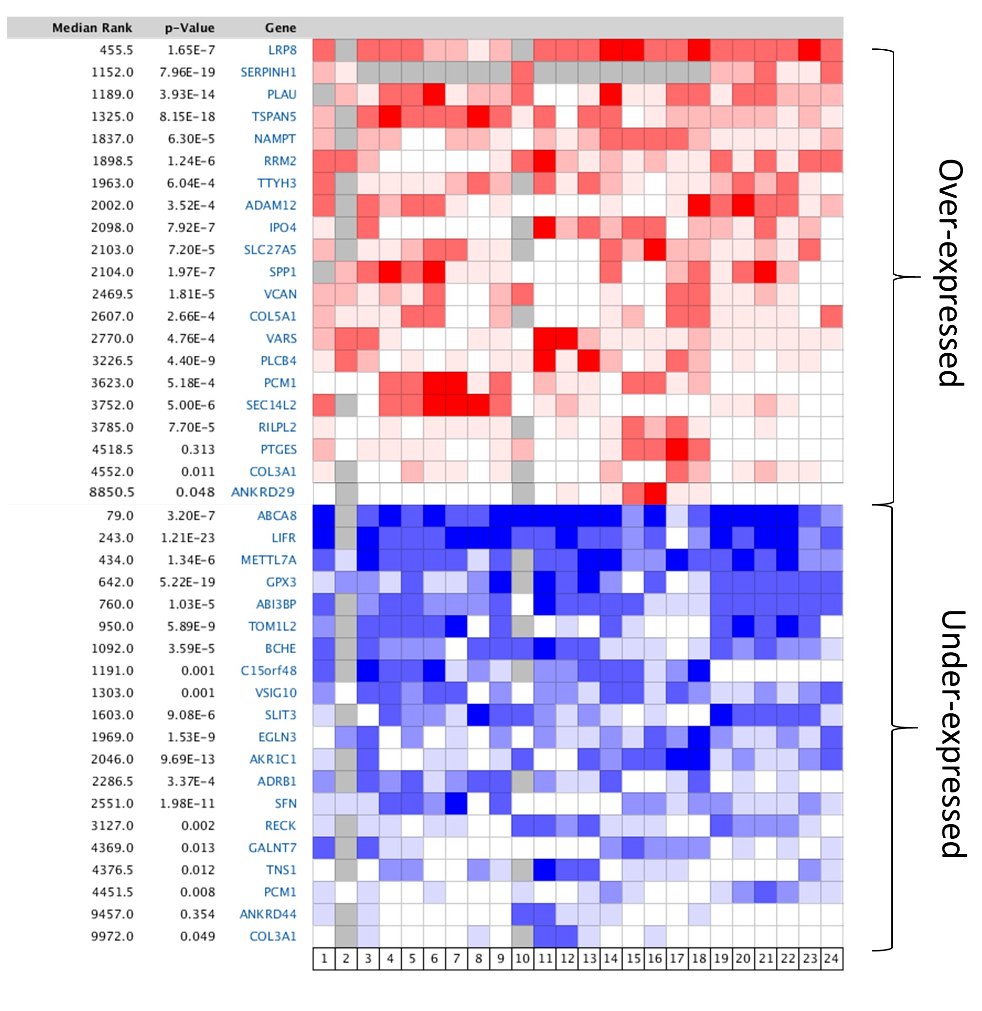

Supplementary Figure 2. Flowchart describing A) training: the process of deriving the NRF2 metagene for prognosis prediction and B) validation: the process of constructing the NRF2 metagene for validation of its prognostic effect.
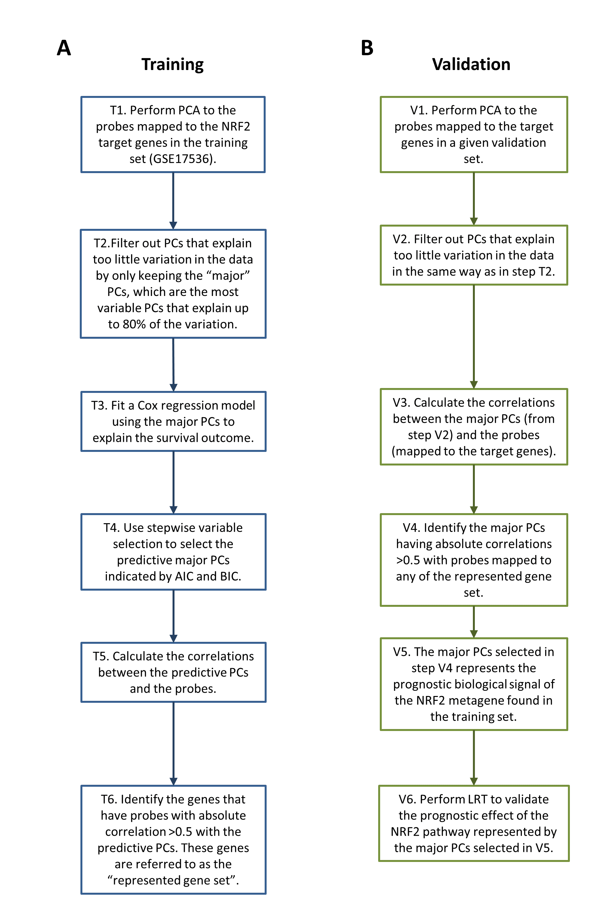

Supplementary Figure 3. Forest plot showing the relative effects of the available prognostic variables within each dataset used in the validation analyses. These variables were used in the multivariate analysis with the NRF2 metagene.
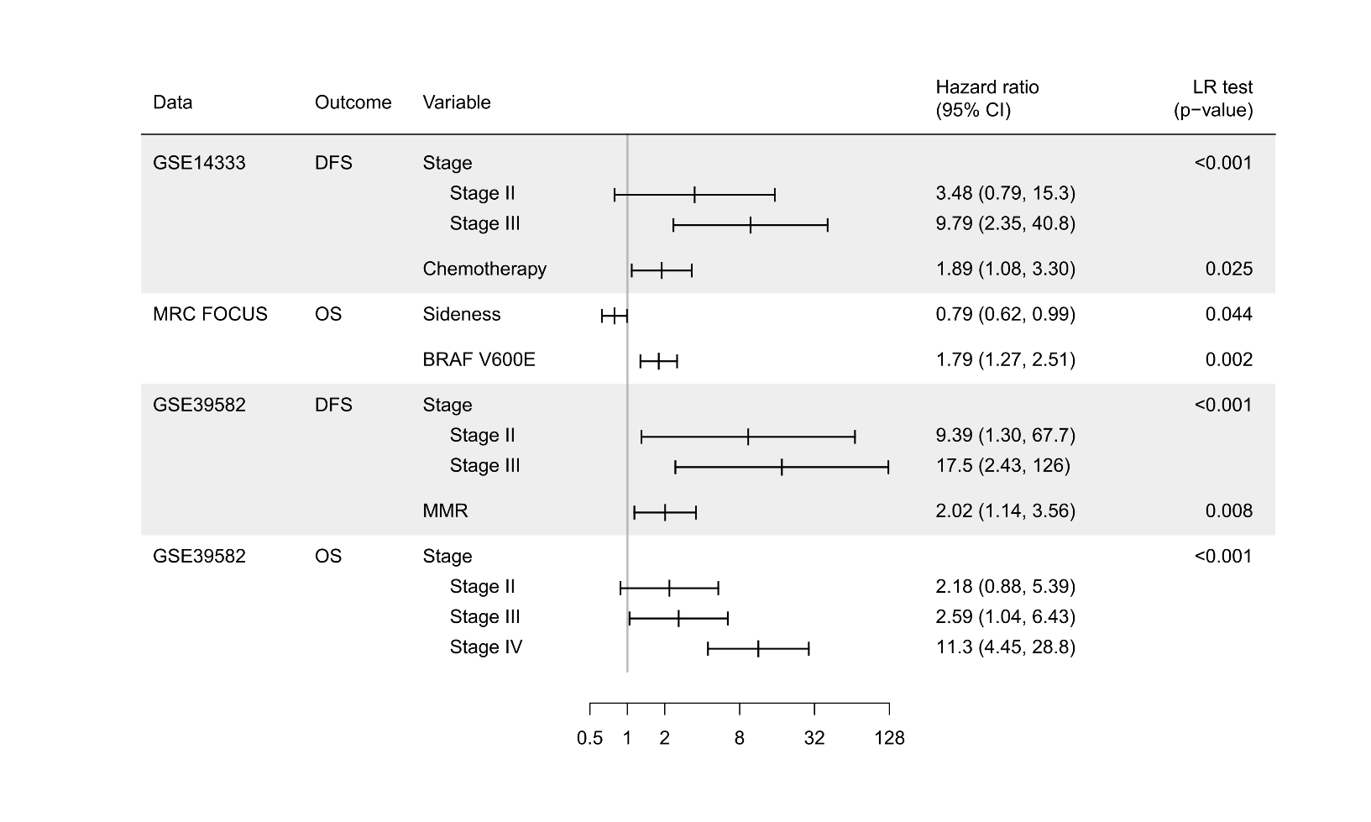
Supplementary Figure 4. Known and predicted protein–protein interactions from the STRING database for the initial 40 genes from the refined differential expression analysis. Genes were clustered by k-means =2 (Green and Red). Central core gene set showed a high degree of connectivity are highly co-expressed in the training set. The line colour indicates the type of interaction and the thickness indicates the strength of interaction (thicker = stronger). [Cyan = known interaction from curated databases; purple = experimentally determined; green = gene neighbourhood; red = gene fusions; dark blue = gene co-occurrences; light green = textmining; black = co-expression; light blue = protein homology]
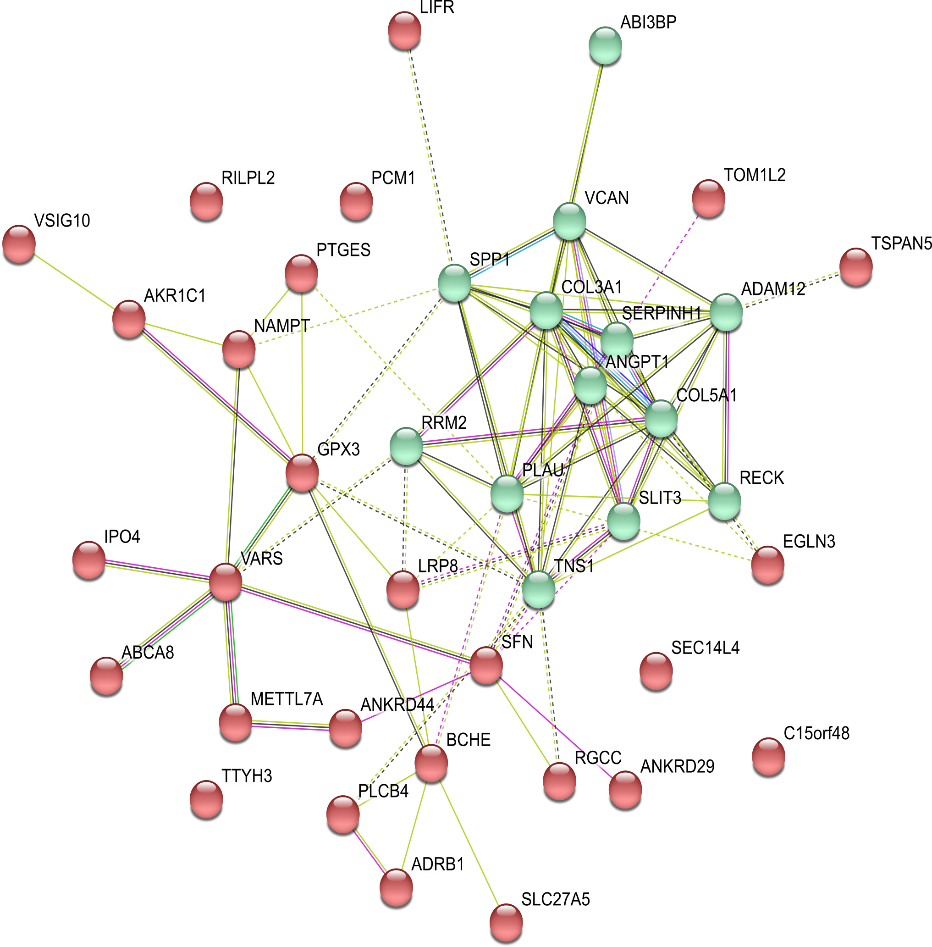
Supplementary Figure 5. Regulatory sequence analysis of the 5000 bp region upstream of the start site of the representative 10 genes which have a high correlation with PC1 in the training set. 9 of these genes contain consensus ARE sites for NRF2 to bind and directly regulate gene transcription.

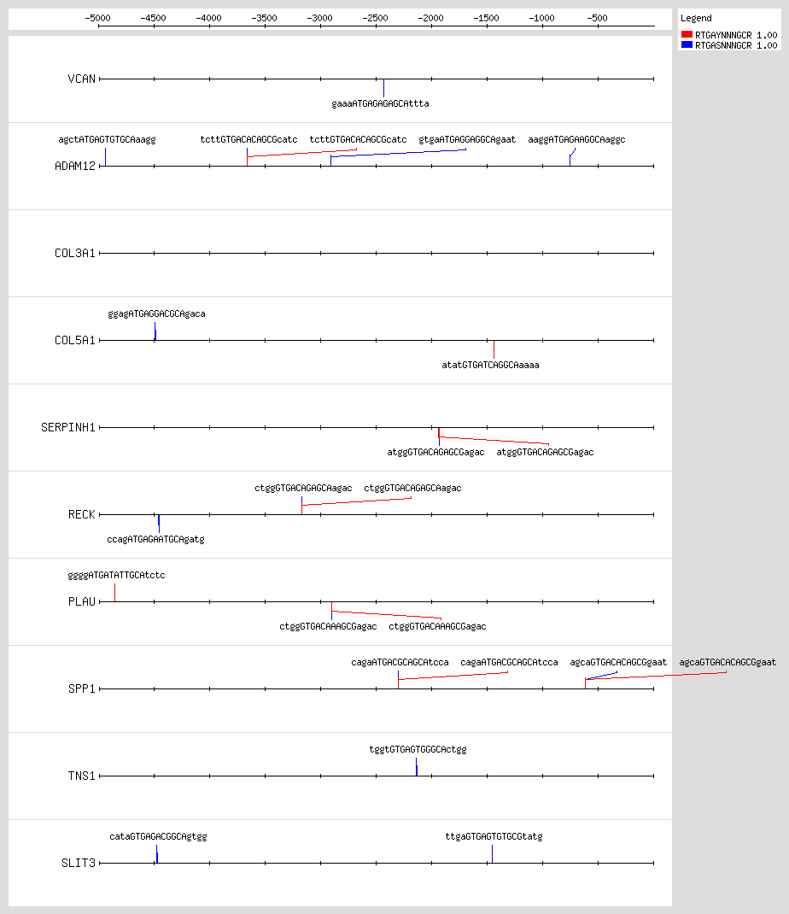

Supplementary Table 2. The list of Affymetrix U133 v2.0 probes used in the analysis and the genes to which they map

Probe ID | Gene | Probe ID | Gene | Probe ID | Gene
1565778_at | ABCA8 | 211424_x_at | METTL7A | 1568574_x_at | SPP1
204719_at | ABCA8 | 244376_at | METTL7A | 209875_s_at | SPP1
220518_at | ABI3BP | 207761_s_at | METTL7A | 218863_s_at | TNS1
223395_at | ABI3BP | 209703_x_at | METTL7A | 221246_x_at | TNS1
1559077_at | ABI3BP | 217739_s_at | NAMPT | 214840_at | TOM1L2
202952_s_at | ADAM12 | 1555167_s_at | NAMPT | 226198_at | TOM1L2
204943_at | ADAM12 | 217738_at | NAMPT | 237109_at | TOM1L2
215613_at | ADAM12 | 243296_at | NAMPT | 209890_at | TSPAN5
213790_at | ADAM12 | 202174_s_at | PCM1 | 225387_at | TSPAN5
226777_at | ADAM12 | 209996_x_at | PCM1 | 225388_at | TSPAN5
208214_at | ADRB1 | 209997_x_at | PCM1 | 224674_at | TTYH3
229277_at | ADRB1 | 214937_x_at | PCM1 | 204620_s_at | VCAN
229309_at | ADRB1 | 214118_x_at | PCM1 | 215646_s_at | VCAN
217626_at | AKR1C1 | 228905_at | PCM1 | 204619_s_at | VCAN
205608_s_at | ANGPT1 | 211668_s_at | PLAU | 211571_s_at | VCAN
1552939_at | ANGPT1 | 205479_s_at | PLAU | 221731_x_at | VCAN
205609_at | ANGPT1 | 203896_s_at | PLCB4 | 223845_at | VSIG10
229308_at | ANKRD29 | 203895_at | PLCB4
238332_at | ANKRD29 | 207388_s_at | PTGES
228471_at | ANKRD44 | 210367_s_at | PTGES
233361_at | ANKRD44 | 1558115_at | RECK
226641_at | ANKRD44 | 1558116_x_at | RECK
235777_at | ANKRD44 | 216156_at | RECK
235778_s_at | ANKRD44 | 205407_at | RECK
205433_at | BCHE | 218723_s_at | RGCC
223484_at | C15orf48 | 239827_at | RGCC
232458_at | COL3A1 | 201890_at | RRM2
201852_x_at | COL3A1 | 209773_s_at | RRM2
215076_s_at | COL3A1 | 216402_at | SEC14L4
203325_s_at | COL5A1 | 207714_s_at | SERPINH1
219232_s_at | EGLN3 | 209260_at | SFN
222847_s_at | EGLN3 | 33322_i_at | SFN
227771_at | LIFR | 33323_r_at | SFN
205876_at | LIFR | 234948_at | SLC27A5
229185_at | LIFR | 203813_s_at | SLIT3
208433_s_at | LRP8 | 216216_at | SLIT3
205282_at | LRP8 | 203812_at | SLIT3
228955_at | LRP8

Supplementary Table 3. The list of Affymetrix Xcel array probes used in the analysis and the genes to which they map
Probe ID | Gene | Probe ID | Gene
ADXECAD.4694_at | ABCA8 | ADXEC.24209.C1_at | ANKRD44
ADXECAD.4694_x_at | ABCA8 | ADXECADA.8703_at | ANKRD44
ADXECEMUTR.2314_at | ABCA8 | ADXECAD.6885_at | ANKRD44
ADXEC.34095.C1_at | ABCA8 | ADXEC.32445.C1_s_at | ANKRD44
ADXEC.34095.C1_x_at | ABCA8 | ADXECEMUTR.1806_at | ANKRD44
ADXECAD.2828_at | ABI3BP | ADXECRS.10687_x_at | ANKRD44
ADXECADA.22250_at | ABI3BP | ADXEC.20524.C1_at | BCHE
ADXECADA.24689_s_at | ABI3BP | ADXEC.5762.C1_at | C15orf48
ADXECADA.13221_at | ADAM12 | ADXEC.10342.C1_at | COL3A1
ADXECADA.16091_at | ADAM12 | ADXEC.1138.C6_s_at | COL3A1
ADXECADA.19748_at | ADAM12 | ADXECAD.16292_at | COL3A1
ADXECADA.22926_at | ADAM12 | ADXECNTDJ.8556_at | COL3A1
ADXEC.10435.C1_at | ADAM12 | ADXEC.1138.C8-a_s_at | COL3A1
ADXEC.24608.C1_at | ADAM12 | ADXEC.1138.C8_s_at | COL3A1
ADXECAD.23192_s_at | ADRB1 | ADXEC.2639.C2_s_at | COL5A1
ADXECRS.43563_s_at | ADRB1 | ADXECEMUTR.7334_at | COL5A1
ADXEC.10477.C1_s_at | ADRB1 | ADXEC.14436.C1_s_at | EGLN3
ADXECADA.7121_s_at | ADRB1 | ADXEC.30477.C1-a_s_at | EGLN3
ADXECEMUTR.4343_at | ADRB1 | ADXEC.30477.C1_at | EGLN3
ADXECEMUTR.4343_s_at | ADRB1 | ADXEC.9508.C1_at | EGLN3
ADXEC.1215.C1_x_at | AKR1C1 | ADXECNTDJ.1518_s_at | LIFR
ADXEC.34313.C1_s_at | ANGPT1 | ADXECNTDJ.8595_at | LIFR
ADXECAD.17898_at | ANGPT1 | ADXEC.28103.C1_s_at | LIFR
ADXECEMUTR.2049_at | ANGPT1 | ADXECAD.15818_at | LIFR
ADXECEMUTR.2049_x_at | ANGPT1 | ADXEC.17620.C1_at | LRP8
ADXECAD.22091_at | ANGPT1 | ADXEC.17620.C1_x_at | LRP8
ADXECNTDJ.6462_s_at | ANGPT1 | ADXECAD.26545_at | LRP8
ADXEC.28165.C1_at | ANGPT1 | ADXECADA.3575_at | LRP8
ADXEC.11758.C1_at | ANKRD29 | ADXEC.15165.C1_at | LRP8
ADXECAD.11878_s_at | ANKRD29 | ADXEC.8514.C1_x_at | METTL7A
ADXPCEC.11748.C1_at | ANKRD29 | ADXECADA.24486_at | METTL7A
ADXPCEC.11748.C1_x_at | ANKRD29 | ADXECNTDJ.5826_s_at | METTL7A
ADXPCEC.865.C1_at | ANKRD29 | ADXECADA.16813_at | METTL7A
ADXPCEC.865.C1_x_at | ANKRD29
ADXEC.4289.C1_at | TOM1L2
ADXEC.32336.C1_at | NAMPT | ADXEC.11904.C1_at | SLIT3
ADXECADA.10815_at | NAMPT | ADXEC.19191.C1_at | SLIT3
ADXEC.2660.C1-a_s_at | NAMPT | ADXEC.19191.C1_x_at | SLIT3
ADXEC.2660.C1_at | NAMPT | ADXEC.4613.C1_at | SLIT3
ADXECAD.1453_s_at | NAMPT | ADXECAD.25829_s_at | SLIT3
ADXECAD.24382_s_at | NAMPT | ADXECADA.16195_x_at | SLIT3
ADXEC.10262.C1_at | PCM1 | ADXECAD.5047_at | SPP1
ADXEC.10262.C1_s_at | PCM1 | ADXECAD.23641_s_at | SPP1
ADXEC.23999.C1_s_at | PCM1 | ADXOCEC.14560.C1_at | SPP1
ADXEC.10262.C2_s_at | PCM1 | ADXOCEC.14560.C1_x_at | SPP1
ADXEC.25350.C1_at | PCM1 | ADXEC.26864.C1_at | TNS1
ADXEC.4679.C2-a_s_at | PLAU | ADXECAD.24662_at | TNS1
ADXECAD.24282_at | PLAU | ADXECEMUTR.2541_s_at | TNS1
ADXEC.21964.C2_at | PLCB4 | ADXEC.3298.C1_at | TNS1
ADXECAD.27780_at | PLCB4 | ADXECADA.10891_at | TOM1L2
ADXECAD.27780_s_at | PLCB4 | ADXEC.13429.C1_at | TOM1L2
ADXECRS.4084_s_at | PLCB4 | ADXEC.4289.C1_at | TOM1L2
ADXEC.21189.C1_s_at | PTGES | ADXEC.21443.C1_at | TSPAN5
ADXECADA.20482_at | PTGES | ADXEC.34129.C1_at | TSPAN5
ADXECADA.20482_x_at | PTGES | ADXECAD.10916_at | TSPAN5
ADXEC.10125.C1_at | RECK | ADXECAD.13537_at | TSPAN5
ADXEC.10125.C1_s_at | RECK | ADXEC.15643.C1_at | TSPAN5
ADXECAD.2455_s_at | RECK | ADXEC.8833.C1_s_at | TSPAN5
ADXECAD.11511_at | RECK | ADXEC.4902.C1_at | TTYH3
ADXEC.25901.C1_at | RGCC | ADXEC.4902.C1_x_at | TTYH3
ADXEC.10181.C1_s_at | RGCC | ADXEC.4902.C2_s_at | TTYH3
ADXEC.3228.C1_s_at | RRM2 | ADXEC.25748.C1_at | VCAN
ADXECRS.44245_at | RRM2 | ADXEC.4587.C1-a_s_at | VCAN
ADXECNTDJ.6564_at | SEC14L4 | ADXEC.4587.C1_s_at | VCAN
ADXECEMUTR.6644_at | SERPINH1 | ADXECAD.17188_at | VCAN
ADXECNTDJ.6701_s_at | SERPINH1 | ADXECAD.17188_s_at | VCAN
ADXEC.1556.C1_at | SFN | ADXECAD.21682_s_at | VCAN
ADXEC.13004.C1_at | SLC27A5 | ADXECEMUTR.4185_s_at | VCAN
ADXEC.13004.C1_s_at | SLC27A5 | ADXECNTDJ.1389_at | VCAN
ADXEC.13004.C1_x_at | SLC27A5 | ADXECRS.7864_s_at | VCAN
ADXECADA.15636_at | SLC27A5 | ADXECADA.19309_at | VSIG10
ADXECNTDJ.6726_at | SLC27A5

Supplementary Table 4. The list of Agilent Human 4 x 44k v2 array probes used in the analysis and the genes to which they map
Probe ID | Gene | Probe ID | Gene
A_23_P118615 | ABCA8 | A_33_P3364864 | NAMPT
A_33_P3342305 | ABCA8 | A_33_P3364869 | NAMPT
A_23_P218858 | ABI3BP | A_33_P3375934 | NAMPT
A_33_P3411975 | ABI3BP | A_23_P82950 | PCM1
A_33_P3411980 | ABI3BP | A_24_P555510 | PCM1
A_23_P350512 | ADAM12 | A_23_P24104 | PLAU
A_33_P3256848 | ADAM12 | A_33_P3306146 | PLAU
A_33_P3310929 | ADAM12 | A_33_P3260634 | PLCB4
A_33_P3310189 | ADRB1 | A_24_P403417 | PTGES
A_24_P152968 | AKR1C1 | A_23_P83028 | RECK
A_23_P216023 | ANGPT1 | A_33_P3269899 | RECK
A_23_P412577 | ANKRD29 | A_24_P225616 | RRM2
A_23_P209347 | ANKRD44 | A_33_P3389286 | SFN
A_24_P128713 | ANKRD44 | A_23_P4611 | SLC27A5
A_23_P212050 | BCHE | A_23_P58588 | SLIT3
A_23_P26024 | C15orf48 | A_33_P3391496 | SLIT3
A_24_P935491 | COL3A1 | A_23_P7313 | SPP1
A_23_P83818 | COL5A1 | A_24_P105733 | TNS1
A_33_P3383351 | COL5A1 | A_33_P3209491 | TNS1
A_33_P3256952 | EGLN3 | A_33_P3738458 | TNS1
A_23_P200222 | LRP8 | A_23_P141180 | TOM1L2
A_23_P415021 | METTL7A | A_33_P3325349 | TSPAN5
 |  | A_23_P331895 | TTYH3
 |  | A_23_P144959 | VCAN

